Methodological instructions for seminars by discipline
Risk management of transgenes
Fall semester, academic year 2021-2022

Seminar 1. The history of the development of the creation of GMOs in biotechnology and methods.

A genetically modified organism (GMO) is not always understood and can vary widely. In the broadest sense, it can include everything that has changed genes, including natural.
In a less broad sense, the term GMO can encompass every organism whose genes have been modified by humans, including all crops and livestock.
The concept of a genetically engineered organism (GEO) is a more accurate term compared to GMO when describing the genomes of organisms that have been directly manipulated using biotechnology. The term GMO was not originally used by scientists to describe genetically engineered organisms until the use of GMO became widespread in popular media [. The United States Department of Agriculture (USDA) believes that GMOs are plants or animals that have been inherited by genetic engineering or traditional methods, while GEO specifically refers to organisms with genes introduced, destroyed, or rearranged using molecular biology, in particular, recombinant DNA techniques such as transgenesis.
The definitions focus on the process more than the product, which means there may be GMOs and non-GMOs with very similar genotypes and phenotypes. This has led scientists to call it a category that has no scientific meaning, stating that it is impossible to combine all the different types of GMOs under one general definition. It has also caused problems for organic organizations and groups looking to ban GMOs. It also creates problems as new processes develop. The current definitions came before genome editing became popular and there is some confusion as to whether they are GMOs. The EU has decided that they will rename their definition of GMOs to include “organisms obtained by mutagenesis

Seminar 2. Methods of genetic engineering as an essential part of agricultural biotechnology. The range of methods includes artificial insemination, in vitro fertilization, sperm bank, cloning and gene manipulation.

In the second half of the 20th century, several important discoveries and inventions were made that underlie genetic engineering. Many years of attempts to "read" the biological information that are "recorded" in the genes have been successfully completed. This work was started by the English scientist Frederick Senger and the American scientist Walter Gilbert (1980 Nobel Prize in Chemistry). As you know, genes contain information-instructions for the synthesis of RNA molecules and proteins, including enzymes, in the body. To force a cell to synthesize new, unusual substances for it, it is necessary that appropriate sets of enzymes be synthesized in it. And for this, it is necessary either to purposefully change the genes in it, or to introduce new, previously absent genes into it. Gene changes in living cells are mutations. They occur under the influence of, for example, mutagens - chemical poisons or radiation. But such changes cannot be controlled or directed. Therefore, scientists focused their efforts on attempts to develop methods for introducing new, completely specific genes into the cell that a person needs.
All methods of genetic engineering are used to implement one of the following stages of solving a genetic engineering problem:
1. Obtaining an isolated gene.
2. Introduction of a gene into a vector for transfer into an organism.
3. Transfer of the vector with the gene into the modified organism.
4. Transformation of body cells.
5. Selection of genetically modified organisms (GMOs) and elimination of those that have not been successfully modified.
Define the following concepts
• Bioengineering
• Biotechnology
• Genetically modified organism
• Genomics
• Genomic library
• Induced stem cells
• Engineering biology
• Use of DNA in technology
• Cloning (biology)
• Molecular genetics
• Synthetic biology
• CRISPR
• BioBrick
• 2A-peptides
• Cell reprogramming

Seminar 3. Application of GMOs and genetic engineering methods for scientific purposes and research. Artificial expression Visualization of gene products.

The gene synthesis process is currently very well developed and even largely automated. There are special devices equipped with computers, in the memory of which programs for the synthesis of various nucleotide sequences are laid. This apparatus synthesizes DNA segments up to 100-120 nitrogenous bases (oligonucleotides). A technique has become widespread that makes it possible to use the polymerase chain reaction for the synthesis of DNA, including mutant DNA. A thermostable enzyme, DNA polymerase, is used in it for template DNA synthesis, for which artificially synthesized pieces of nucleic acid, oligonucleotides, are used. The enzyme reverse transcriptase allows using such primers to synthesize DNA on a template isolated from RNA cells. DNA synthesized in this way is called complementary (RNA) or cDNA. An isolated, "chemically pure" gene can also be obtained from a phage library. This is the name of a bacteriophage preparation, into the genome of which random fragments from the genome or cDNA are inserted, reproduced by the phage along with all its DNA.
Restriction enzymes and ligases, which are also useful genetic engineering tools, are used to insert a gene into a vector. Using restriction enzymes, the gene and vector can be cut into pieces. With the help of ligases, such pieces can be "glued", connected in a different combination, constructing a new gene or enclosing it in a vector.
The technique of introducing genes into bacteria was developed by the discovery of the phenomenon of bacterial transformation.
The transformation is based on a primitive sexual process, which in bacteria is accompanied by the exchange of small fragments of nonchromosomal DNA, plasmids. Plasmid technologies formed the basis for the introduction of artificial genes into bacterial cells.
Significant difficulties were associated with the introduction of a ready-made gene into the hereditary apparatus of plant and animal cells. However, in nature, there are cases when foreign DNA (of a virus or bacteriophage) is included in the genetic apparatus of a cell and, with the help of its metabolic mechanisms, begins to synthesize its “own” protein. Scientists investigated the peculiarities of the introduction of foreign DNA and used it as a principle of introducing genetic material into the cell. This process is called transfection.
If unicellular organisms or cultures of multicellular cells undergo modifications, then at this stage cloning begins, that is, the selection of those organisms and their descendants (clones) that have undergone modification. When the task is set to obtain multicellular organisms, then cells with a changed genotype are used for vegetative propagation of plants or injected into the blastocysts of a surrogate mother when it comes to animals. As a result, babies are born with an altered or unchanged genotype, among which only those that show the expected changes are selected and crossed with each other.

Gene knockout. A gene knockout can be used to study the function of a particular gene. This is the name of the technique of removing one or more genes, which allows you to study the consequences of such a mutation. For a knockout, the same gene or a fragment thereof is synthesized so that the gene product loses its function. The main methods of implementation: zinc finger, morpholino and TALEN. To obtain knockout mice, the obtained genetically engineered construct is introduced into embryonic stem cells, where the construct undergoes somatic recombination and replaces the normal gene, and the altered cells are implanted into the blastocyst of a surrogate mother. In the fruit fly, Drosophila mutations are initiated in a large population, in which offspring with the desired mutation are then sought. Plants and microorganisms are knocked out in a similar way.
Artificial expression. A logical addition to a knockout is artificial expression, that is, the addition of a gene to the body that he did not have before. This genetic engineering technique can also be used to study the function of genes. In essence, the process of introducing additional genes is the same as for knockout, but existing genes are not replaced or damaged.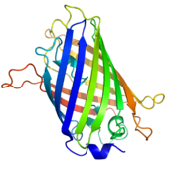
Diagram of the structure of green fluorescent protein

Gene product visualization. Used when the task is to study the localization of a gene product. One of the methods of labeling is the replacement of a normal gene with a fusion with a reporter element, for example, with the green fluorescent protein (GFP) gene. This protein, which fluoresces in blue light, is used to visualize the gene modification product. Although this technique is convenient and useful, its side effects can be partial or complete loss of function of the protein under investigation. More sophisticated, although not so convenient the method is to add to the protein under study not so large oligopeptides that can be detected using specific antibodies.
Investigation of the expression mechanism. In such experiments, the task is to study the conditions of gene expression. The features of expression depend primarily on a small piece of DNA located in front of the coding region, which is called a promoter and serves to bind transcription factors. This site is introduced into the body, after which, instead of its own gene, a reporter, for example, GFP or an enzyme that catalyzes an easily detectable reaction, is inserted. In addition to the fact that the functioning of the promoter in certain tissues at one time or another becomes clearly visible, such experiments allow one to study the structure of the promoter by removing or adding DNA fragments to it, as well as to artificially enhance its functions.

Seminar 4. Genetically modified food. Examples, use.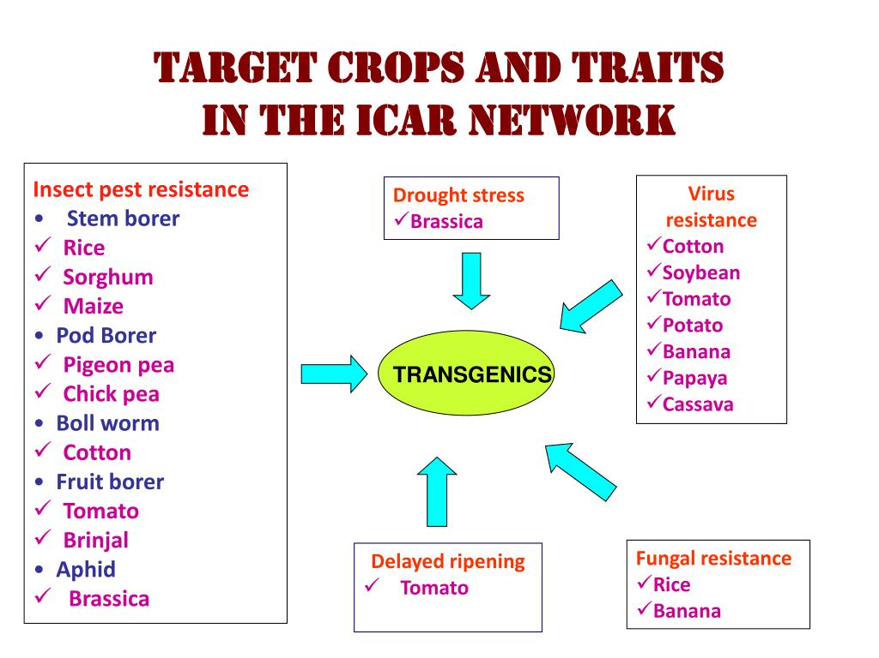 Health risk

Certain gene products that are genetically engineered into the body can be harmful. The lectin gene from the Galanthus ni-valis snowdrop has been inserted into the potato to improve its resistance to nematodes. Feeding potatoes to rats demonstrated the toxic effect of the genetically modified cultivar. The publication of the data was preceded by a loud scandal, as the results were presented before the expert evaluation by other scientists. The explanation proposed by Empty that the toxic effect, most likely, was caused not by lectin, but by the method of gene transfer, is not supported by most scientists, since the data presented in the article are insufficient to formulate just such conclusions. The development of a transgenic potato with a lectin gene has ceased.
The modern methodology for the admission of transgenic plants to use provides for a chemical analysis of the composition in comparison with conventional products and research on experimental animals. A separate subject of discussion is the design of animal experiments. Russian researcher Irina Ermakova conducted a study on rats, which, in her opinion, demonstrates the pathological effect of genetically modified soybeans on the reproductive qualities of animals. Since the data were widely discussed in the world press, without being published in peer-reviewed journals, the scientific community considered the results more carefully [. A review of six world-class independent experts led to the following conclusions regarding this experience: A review of six world-class independent experts led to the following conclusions regarding this experience:

Seminar 5. Perspectives and risks associated with GM food. Migration of genes due to cross-pollination
Food Allergies That May Be Associated With GMOs
Toxicity that may be associated with GMOs.
Transgenes can affect the environment if they enter wild populations and are stored there. This also applies to conventional breeding. The following risk factors should be considered:
• whether transgenic plants are able to grow outside the cultivated area;
• whether the transgenic plant can pass on its genes to local wild species and whether the hybrid offspring will be fertile;
• whether transgenes give their carriers a selective advantage over wild plants.
Many domesticated plants can interbreed with wild relatives when they grow in close proximity, and in this way the genes of the cultivated plants can be passed on to the hybrids. This applies to both transgenic plants and conventional breeding varieties, since in any case we are talking about genes that can have negative consequences for the ecosystem after being released into the wild. This is usually not a major concern, despite concerns about “mutant superstorms” that could overwhelm local wildlife. Although hybrids between domesticated and wild plants are far from uncommon, in most cases these hybrids are not fertile due to polyploidy and do not persist in the environment for a long time after the domesticated plant variety is withdrawn from cultivation. However, this does not exclude the possibility of negative impact.
The pollen of domesticated plants can spread for miles with the wind and fertilize other plants. This can complicate the assessment of the potential loss from cross-pollination, since potential hybrids are located far from the test fields. To solve this problem, systems are proposed that are designed to prevent the transfer of transgenes, for example, terminator technologies and methods of genetic transformation of chloroplasts exclusively so that pollen is not transgenic. With regard to the first direction of terminator technology, there are prerequisites for the unfair use of technology, which can contribute to greater dependence of farmers on producers. The genetic transformation of chloroplasts does not have such features, but it has technical limitations that still need to be overcome. To date, there is still not a single commercial cultivar of transgenic plants with a built-in system for the prevention of cross-pollination.
Safety: the product must be safe and not pose a threat to the health of people or animals. Also, it must be safe for the environment. Safety is determined according to developed tests, which are based on the latest scientific knowledge and are applied using modern technological means. If a product does not meet the above requirements, it does not receive permission for cultivation or distribution. If, over time, hazardous properties are identified in a product, it is excluded from the market.
The right to choose: even if GMOs receive permission to cultivate or distribute, consumers, farmers and businesses should have the right to choose whether to use it or not. This means that in the long term it should be possible to manufacture products without the use of genetic engineering.
Ensuring the principle of the right to choose is possible provided that two rules are observed:
Marking: the most important way to ensure the right to choose. Wherever and how GMOs are used, they must be clearly labeled. In this case, the consumer has the opportunity to make an informed choice.
Tracking: labeling is also necessary, even if GMOs cannot be traced in the residual product. This applies to manufacturers and suppliers of products. In this case, they undertake to inform consumers by issuing responsible documentation regarding raw materials.
The tolerance for one genetically modified crop in one country is estimated from 6 to 15 million US dollars, this includes the costs of preparing the request, assessment of molecular characteristics, composition and toxicity of the product, animal studies, characterization of proteins for allergenicity, assessment of agronomic qualities, development of testing methods, preparation of legal documents for the organization of export. The costs are paid by the person applying for admission.

Seminar 6. Gene migration through horizontal gene transfer. Compositional equivalence.
Migration of transgenes into natural populations due to horizontal gene transfer. The natural mechanism of transmission of bacterial DNA by means of a Ti-plasmid from soil bacteria of the genus Agrobacterium to dicotyledonous plants is known, followed by the insertion of plasmid DNA into the plant genome. The reverse process of the transfer of genetic material from plants to bacteria in nature has not yet been recorded, although a number of successful attempts have been made to implement this process in laboratory conditions. This type of horizontal gene transfer raises concerns due to the prevalence of plant GMOs and their close contact with soil microorganisms. There is an opinion that this increases the danger of the transfer of their marker genes of resistance to antibiotics, undesirable from the point of view of biosafety for human and domestic animal health, to soil microorganisms. In turn, such bacteria can transfer transgenes to pathogens using LHG.
A separate note of ecologists is the use of the gene from nptII of Escherichia coli, which gives resistance to the antibiotic kanamycin, as a selective marker. Most commercial transgenic plants contain it. It is believed that this gene can get into the soil with the remains of plant DNA, and from there into the genome of soil bacteria. As a result, this will lead to fixation of antibiotic resistance in the bacterial population and its transfer to pathogenic bacteria.
The DNA of transgenic plants really remains in the soil for some time, although it degrades. In addition, bacteria are able to "import" alien genes into their own genome. The frequency of such an event in vivo on Acinetobacter bacteria was determined: transfer of a circular plasmid 1.9 x 10-5 into the bacterial genome, a linearized molecule 2.0 x 10-8, transfer of DNA from transgenic residues - less than the measurement sensitivity limit 10 -11
For genetically modified foods, the principle of "compositional equivalence" (en: substantial equivalence) is applied in many countries. This means that a GM crop is considered not to carry more risks than a conventional crop of the same species if they have the same chemical composition parameters, especially the nutrient content. Some scientists criticize this approach, since the relationship between chemical composition, biochemistry and genetics is still not fully understood, and there is a possibility of the existence of currently unknown harmful substances, the content of which may change as a result of genetic modification. For example, an article published in 2012 compared the properties of a conventional (MG-BR46 Conquista) and a transgenic (BRS Valiosa RR) glyphosate-resistant soybean based on it. It has been shown that both common and transgenic soybeans, when eaten, have a protective effect against DNA damage in mice, but in transgenic soybeans this effect is, on average, more than 2 times lower. The study authors noted that their results correlate with an earlier comparison of the properties of regular and transgenic soybeans (with the same gene modification CP4 EPSPS). In this 2010 study, the anti-mutagenic effect of a diet with 10% and 20% regular soybeans, as well as 10% transgenic, was observed. A diet with 20% transgenic soybean content did not have such an effect, and also statistically significantly reduced the mitotic index (which indicates cytotoxic activity). On the other hand, as a result of a 15-day study, no histological changes in the vital organs of all groups of mice were found. Based on the data obtained, the authors concluded that further research on the causes leading to the observed harmful or protective actions of soybeans is necessary.

Seminar 7. Methods of risk assessment (stages of risk assessment).
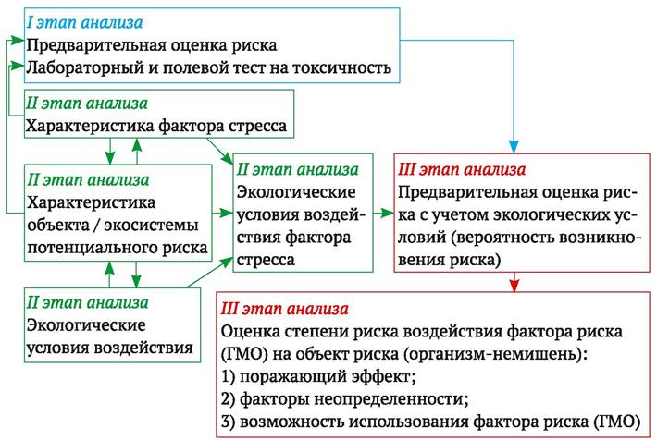

The task of changing the genome of an adult is somewhat more difficult than breeding new genetically engineered animal breeds, since in this case it is required to change the genome of numerous cells of an already formed organism, and not just one egg-embryo. For this, it is proposed to use viral particles as a vector. Virus particles are able to penetrate into a significant percentage of adult cells, embedding their hereditary information in them; possible controlled multiplication of viral particles in the body. At the same time, in order to reduce side effects, scientists try to avoid the introduction of genetically engineered DNA into the cells of the genital organs, thereby avoiding exposure to the patient's future descendants. It is also worth noting the significant criticism of this technology in the media: the development of genetically engineered viruses is perceived by many as a threat to all mankind.
With the help of gene therapy, it is possible to change the human genome in the future. Currently, effective methods of altering the human genome are at the stage of development and testing in primates. For a long time, genetic engineering of monkeys faced serious difficulties, but in 2009 the experiments were crowned with success: the journal Nature published a publication on the successful use of genetically engineered viral vectors to cure an adult male monkey from color blindness. In the same year, the first genetically modified primate (grown from a modified egg), the common marmoset (Callithrix jacchus), gave birth to its offspring.
Albeit on a small scale, genetic engineering is already being used to give women with certain types of infertility a chance to become pregnant. For this, the eggs of a healthy woman are used. As a result, the child inherits the genotype from one father and two mothers.
However, the possibility of making more significant changes in the human genome faces a number of serious ethical problems. In 2016, a group of scientists in the United States received approval for clinical trials of a cancer treatment method using the patient's own immune cells, which are genetically modified using CRISPR / Cas9 technology.
At the end of 2018, two children were born in China, whose genome was artificially altered (the CCR5 gene was turned off) at the embryo stage using the CRISPR / Cas9 method, as part of research conducted since 2016 to combat HIV. One of the parents (father) was HIV-positive, and the children, according to the statement, were born healthy. Since the experiment was unauthorized (before that, all such experiments on the human embryo were allowed only in the early stages of development, followed by the destruction of the experimental material, that is, without implanting the embryo into the uterus and giving birth to children), the scientist responsible for it did not provide evidence for his claims which were made at the international conference on genome editing. At the end of January 2019, the Chinese authorities officially confirmed the facts of this experiment. In the meantime, the scientist was forbidden to engage in scientific activities, and he was arrested.
Seminar 8 Methodology for conducting risk assessment (stages of risk assessment): basic principles.
Despite the difference in approaches to organizing risk assessment of genetic engineering activities in different countries, its essence (methodology) is similar in its main features. The Cartagena Protocol on Biosafety to the Convention on Biological Diversity recommends the following methodology for conducting risk assessment (stages of risk assessment):
1) identification of any new genotypic and phenotypic characteristics associated with a living modified organism that may adversely affect biological diversity in the likely potential host environment, taking into account the risks to human health;
2) assessment of the degree of probability of the actual occurrence of such unfavorable consequences, taking into account the intensity and nature of the impact of the living modified organism on the likely potential receiving environment;
3) assessment of the consequences in the event that such an adverse impact will actually take place;
4) an assessment of the cumulative risk caused by a living modified organism, based on an assessment of the likelihood of occurrence and the identified consequences of an adverse impact;
5) making a recommendation as to whether the risks are acceptable or manageable, including, if necessary, defining strategies to manage such risks.
In this case, the risk assessment should be based on the following principles:
• risk assessment should be carried out on a scientific basis, in a clear, adequate manner, based on scientific and technical data appropriate to the subject matter;
• risk assessment should be carried out on a case-by-case basis, sequentially, step by step, implying that the required information varies depending on the type of GMO considered, its intended use and potential release medium;
• the risks associated with GMOs or products containing them should be considered in the context of the risks associated with the use of
intact (unmodified) recipient organisms in a potential receiving environment;
• if new information becomes available about GMOs and their impacts on human health and the environment, the results of the risk assessment may be revised to determine whether the degree of risk has changed and whether there is a need to change the risk management system.
Seminar 9. Intentional effect of foreign DNA insertion into GMOs (manifestation of target traits of genetic modification). Unintended effects of genetic modification (GEM)
Mechanisms of Genetic Modification Effects (GEM)
The main group of risks associated with GMOs is based on the adverse effects caused by the transfer of transgenes to other organisms: vertical gene transfer from GMOs to unmodified plants of the same species or wild relatives of a cultivated species, horizontal gene transfer, for example, selective genes for antibiotic resistance -kam, from a genetically modified plant to microorganisms of the digestive tract. Genes and their products, which are harmless in GMOs, can turn out to be dangerous in a different genetic and ecological environment. Thus, the acquisition of antibiotic resistance by pathogenic bacteria of the digestive tract can significantly complicate the treatment of diseases that they can cause.
Seminar 11. Reduction of biological diversity as a result of changes in natural biocenoses during the cultivation of transgenic plants Analysis of possible adverse effects on human health of food additives (dyes, emulsifiers, preservatives, etc.) and food contaminants (pesticide residues, medicinal veterinarians). drugs, hormonal drugs, mycotoxins, etc.).

Biological diversity is not only the basis for the stable existence of life on Earth, but also a source of the richest resources for human life. Genetic diversity is the foundation and integral part of biological diversity. Genetic diversity is understood as variation of genes or allelic diversity of genes within a population (an elementary unit of evolution) and a species. Genetic diversity is vital for the existence of a population and a species as a whole, since it allows them to adapt to changing environmental conditions and survive both in the current and new conditions of existence. Thus, genetic diversity is the foundation of species diversity and ecosystem stability.
Biological and genetic diversity is considered as a world heritage of mankind, and in any country of the world - as a national treasure, the use and exploitation of which should be regulated by state laws (Convention on Biological Diversity, principle 2). The potential of biodiversity, which humanity can use without harming the environment for its stable existence and development, has not yet been fully explored, is used only partially, and sometimes quite.
• possible increased invasiveness and aggressiveness of some GMOs, which can lead to the suppression and displacement of the same species as GMOs, as well as other types of the ecosystem that are not able to compete with GMOs for living space or food supply;
• inappropriate action of GMOs with toxic properties, which can lead to a decrease in the number of not only pests, but also neutral and useful species, lead to disruptions in ecological relations with the participation of these species (interruption of the food chain, disappearance of the pollinator, violation of biological control of the number pests);•
the consequences of the migration of transgenes from GMOs to their wild relatives.
The sources of the danger of reducing species and genetic diversity, which are associated not so much with the use of GMOs, but with the natural desire of people to maximize profits in the production of agricultural products, are:

• the use of monoculture in agricultural production, which leads, on the one hand, to a decrease in the diversity of biocenoses in the agricultural environment and, accordingly, to a decrease in the species diversity of organisms usually living in biotopes of the agricultural environment. On the other hand, a monoculture becomes a source of reduced genetic diversity, which can lead to a decrease in the adaptive capabilities of a culture and become a source of selective pressure in populations of its pest;

• the use of a limited number of the most economically profitable varieties and the displacement of local varieties and races, which are the sources of many selectively valuable traits, which leads to a decrease in genetic diversity and the loss of many valuable alleles and genes, which could subsequently be required when improving existing agricultural crops.
If the first two sources can theoretically lead to a decrease in the number and loss of any biological species (to a decrease in biological species diversity), then the migration of transgenes does not lead to a decrease in the species diversity of the ecosystem and does not necessarily affect the number of the recipient species of the transgenic trait. However, it leads to a change in the existing genetic diversity in the recipient population of a related species and may affect its adaptive properties.

Seminar 12. Criteria for a new product (plant variety).

A new product (plant variety) can be:
• equivalent (equivalent) in terms of essential characteristics to the selected analogue;
• an equivalent analogue, with the exception of one (several) essential, well-defined features;
• not equivalent to the analogue in terms of essential features.
In the latter two cases, a thorough safety assessment of GMO traits different from the original analogue is carried out in terms of such indicators as potential toxicity, potential allergenicity, the possibility of transfer of antibiotic resistance genes to microorganisms of the digestive tract, the likelihood of a potential deterioration in nutritional value and absorption of nutrients. ...
International electronic databases for the assessment of toxicity and allergenicity of peptides
Seminar 13. Proteins - the main products of transgenes of commercially used GMOs
The most common transgenic products of commercially used GMOs are certain proteins. Therefore, the procedure for assessing their potential toxicity is discussed in more detail below. It is known that there are a number of important differences in the toxic effects of proteins and industrial chemicals of a non-protein nature on humans. Proteins are usually non-toxic in acute experiments on model animals, and there are no known cases of them showing chronic toxicity, for example, having mutagenic, carcinogenic effects. Individual protein toxins are well studied and highly specific.
Proteins, unlike chemicals, are usually quickly digested in the human gastrointestinal tract and are deactivated. They also do not bioaccumulate (accumulate) like some harmful chemicals. Taking into account these features, the assessment of the toxic potential of transgenic proteins is somewhat different from the above procedure for assessing the toxicity of industrial and other food contaminants. It is designed to provide answers to the following questions:
• What is the expected amount of the estimated protein in the normal human diet?
• Does the new protein being assessed cause reported adverse (toxic) effects when consumed in amounts significantly in excess of established intakes?
• Is the new protein of interest being digested in the human gastrointestinal tract?
• Is the new assessed protein degraded during food processing?
An assessment of the content of a new protein in a normal human diet is necessary for further analysis of its potential toxicity (adverse toxic effects in most cases depend on the dose of the toxic agent). Data on the probable consumption of the investigated agent are collected depending on the specifics of the diet of different groups of the population: national groups, age groups, lactating mothers, etc. components of a variety of food products. The amount of transgenic proteins consumed is usually minimal compared to the total amount of protein consumed. However, even it can theoretically cause adverse reactions to human health.
The basic element of studying the structure of proteins encoded by an inserted gene is the assessment of their correspondence to known amino acid sequences, primarily the protein product of the proposed transgene (when inserted into the genome, it is possible to change the structure of the insert's DNA). For this, the implementation of the DNA sequence of the protein-coding part of the transgene is mandatory. The information obtained is also used to assess the homology of the amino acid sequence of the protein product of the transgenic insert with known toxins and allergens, for which the relevant information from international databases is used (Table 11.1). It is desirable to carry out sequencing of the expressed part of the inserted DNA. MRNA is isolated from the transgenic plant, cDNA is obtained on its basis, then the cDNA fragment is amplified with primers specific for the transgenic insert or its individual parts (RT-PCR method; see section 9.6), the amplification products are eluted from the gel and sequenced. The analysis of the sequencing results is carried out using special computer programs, for example, a software package
Seminar 14. Procedure for assessing the risk of the allergenic potential of the source of transgenes (potential allergenicity of the donor organism).
The risk assessment procedure begins with characterizing the allergenic potential of the transgenic source (potential allergenicity of the donor organism). Protein is a transgene product that has never caused an allergic reaction when consumed and will not most likely cause one when expressed in a transgenic organism. Based on this, at the first stage of risk assessment, using the available information, it is established: whether the source of transgenes is a generally recognized (main) or minor allergen, or it is not a known allergen. If the source of the transgene belongs to the above eight major or 160 minor allergenic sources, then the resulting GMO and the corresponding food products are considered allergenic until proven otherwise.
After establishing the allergenic potential of the donor organism, the next step in the adopted procedure is to compare the amino acid sequence of all new proteins - transgenic products from allergenic and non-allergenic sources with the amino acid sequence of known allergens. At present, the amino acid sequence of more than 200 allergens has been identified and special computer databases have been created to compare the structure of the target proteins of GMOs and allergens (see Table 14.1).
The purpose of the amino acid sequence comparison is to establish whether the protein synthesized is structurally similar to known allergens. Structural similarity is considered established if 35% sequence identity of random fragments of 80 amino acids or complete identity of 6 consecutive amino acids in the compared proteins is found (probable minimal linear epitope).
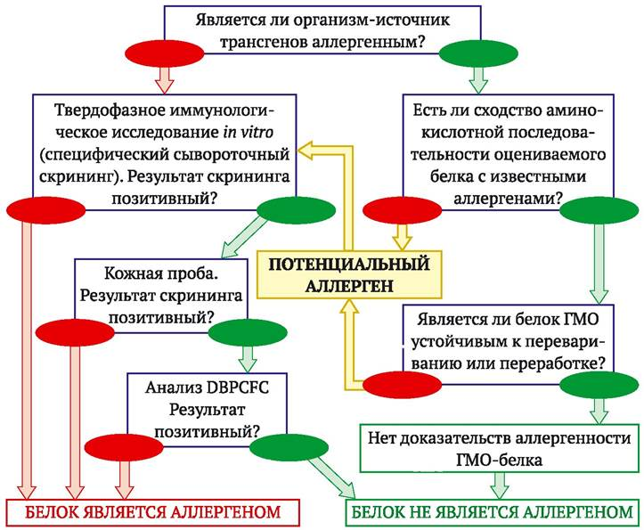
Figure. 14.1. Assessment of the risk of allergenicity of GM foods. Sequence of tests and solutions proposed by FAO / WHO experts (FAO / WHO, 2001; http://www.fao.org/es/csn/gm/biotech-e.htm)

Seminar 15. Mechanisms of horizontal gene transfer (LGT), providing the manifestation of new traits in the recipient organism.

Several mechanisms of horizontal gene transfer (LHT) are known in nature, which can provide the manifestation of new traits in a recipient organism.
Among them are conjugation and transduction, which play an essential role in the exchange of genetic information between prokaryotic organisms (mainly between bacteria).

Another mechanism, the so-called natural transformation, is more important for assessing the risk of LHG when using GM plants. It provides for the active transfer of free extracellular DNA into the cytoplasm of a bacterial cell. A fragment of single-stranded DNA captured by a bacterial cell can theoretically integrate into a bacterial genome due to homologous recombination or the formation of an autonomous replicative element (plasmid).
The specificity of plant genetic engineering is such that transgenes relatively often contain nucleotide sequences homologous to prokaryotic, which significantly increases the likelihood of their integration into the bacterial genome.

